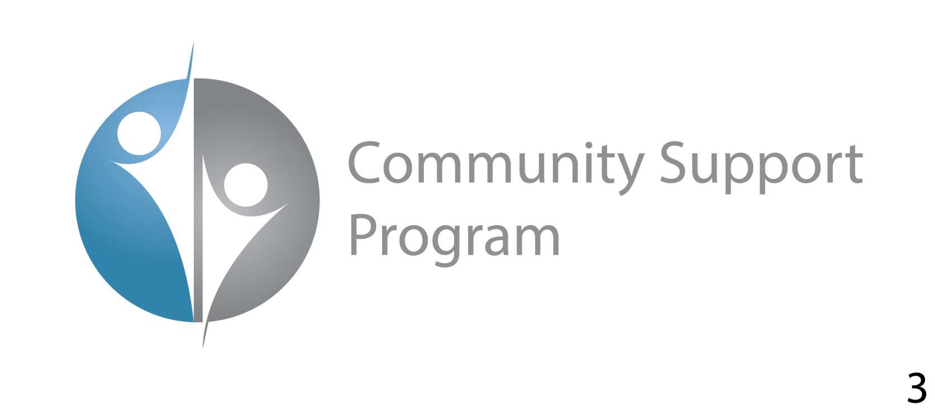

**Community Support Program Statement on the Release of the RAND Preliminary Report**

**1/27/2021**

We are glad that the RAND Corporation has found that our Baltimore AIR Program increased the rate at which police solved serious crimes. <https://www.rand.org/news/press/2021/01/27.html> This is the first rigorous independent evaluation of this new program. Increasing case clearances within the first 6 months of implementation is very significant. Based on the RAND data, cases that we supported cleared at a 50.9% higher rate then those cases we did not support. That includes a 59.4% increase in clearance rates for homicides, an 85.4% increase of shootings, and an 88.7% increase for carjackings. Longer implementation and closer integration with detectives, prosecutors, and other police systems will increase the impact significantly over time. We are also glad that RAND showed statistically significant impact (P=0.04) on hard cases where detectives need the most help.



We are also very happy that Baltimore is one of just a couple US cities in 2020 that have been able to reduce its homicide rate.  There are many reasons for these results but we hope we have helped contributed to that result.

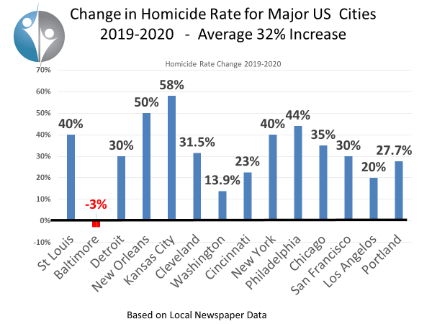

We are proud of our efforts.  We faced some unusual times with COVID lockdowns, protests keeping us from our office, to the remnants of no less than 5 tropical storms blowing through Baltimore area during the program but we are happy we were able to help close so many cases.

We hope more of the cases where we provided a significant amount of information will close and remove the criminals from the streets. There are a significant number of cases we felt were close to closing and hope they will close soon as the people we witnessed conduct those crimes need to be stopped and the families deserve justice.  It is the close cases that have not closed that we think most about as they represent the biggest threat to the community as those individuals are still on the street.

We also want to thank the University of Baltimore for their independent research on Public Acceptance of the AIR Program. There report can be found at <http://www.ubalt.edu/news/news-releases.cfm?id=3661>. Their research shows that the people of Baltimore support the AIR program by more than 2-1 margin (55% support to 27% oppose) and our efforts to reduce crime within the city.

We want to thank all the researchers who have worked on the evaluation of the AIR program. We appreciate the effort, and we are glad to have the results.  We know that our staff will be glad to see that they had an impact and contributed to helping make Baltimore a safer place to live.

We are very proud of our staff of dedicated Baltimore analysts who recognize the impact they have had and can have on helping cities become safer. They will never know who was saved by removing the repeat offenders earlier in their criminal career or who was saved by a potential criminal who was deterred from committing crime because of their efforts.  The ultimate goal of the program is to avoid the crime in the first place.  Sometimes just knowing that we contributed to help save people who we will never know is especially rewarding.

We want to thank Commissioner Harrison for allowing us to opportunity to support the people of Baltimore, BPD’s legal team who provided great representation for the city, and the CitiWatch program who collaborated with our analysts to leverage the existing camera infrastructure thereby drastically increasing the effectiveness of both systems. We want to especially thank the hardworking BPD officers and detectives who risk their lives to protect the city every day.

We want to specifically thank the Arnold Ventures and John and Laura Arnold for their support and patience as we and the community worked for many years to make this evaluation possible.  Without your support, this effort to help the people of Baltimore would never have happened and it would not be possible to show the impact our program can have helping the people who live in troubled cities.

It takes courage to try something new and untested.  The efforts in Baltimore City will allow others the opportunity to look to the results and make informed decisions. We look forward to helping create safer communities for all, to help make them better places to live work and play and to raise kids and families.

Thank you all and God Bless.

Very sincerely,

Ross McNutt

Director, Community Support Program mcnuttr@pss-1.com

# <https://www.rand.org/news/press/2021/01/27.html>

# Preliminary Report Suggests Baltimore Aerial Investigations Research Pilot Was Associated with Small Improvements in Solving Crimes

For Release

Wednesday January 27, 2021

A preliminary report about an effort to use aerial surveillance to aid police investigations in Baltimore finds that the effort was associated with small increases in the rate at which police solved serious crimes, but an overall evaluation of the program will require a wider review of citywide police efforts, according to a new RAND Corporation [report](https://www.rand.org/pubs/research_reports/RRA1131-1.html).

The report does not draw conclusions about the effectiveness of the Aerial Investigations Research pilot that ran from May to October 2020.

RAND researchers concluded that preliminary evidence on case outcomes suggest the program may have helped police solve an additional 11 serious crimes during the six-month trial.

Making conclusions about the overall effectiveness of the program will require an analysis of citywide crime and policing outcomes—information that was not yet available for the preliminary evaluation. RAND researchers expect to release an assessment of the overall effectiveness of the program in April 2022.

“Our report outlines a few preliminary findings based on case outcomes to date, but some of these outcomes may change as the Baltimore police continue to investigate crimes that occurred during the pilot period,” said [Andrew Morral](https://www.rand.org/about/people/m/morral_andrew_r.html), lead author of the report and a senior behavioral scientist at RAND, a nonprofit research organization. “This is an innovative intervention and our evaluation of how crime and police investigations changed in Baltimore from before to during and then after the pilot will require another year to complete.”

The Aerial Investigations Research program involved having airplanes equipped with powerful cameras fly above the city during daylight hours, capturing a second-by-second record of outdoor events.

Images taken from the aircraft could be used to support crime investigations by allowing analysts to track suspects as they approached and departed the crime scene. Although image resolution was too poor to identify individual's characteristics, by tracking them through the city analysts were often able to identify when suspects or their vehicles passed CitiWatch closed-caption television cameras or police license plate scanners, which could provide more detailed information about suspects' identities.

The Aerial Investigations Research pilot program was designed to help police investigations of four types of crime—homicides, nonfatal shootings, armed robberies, and carjackings.

Although the aerial surveillance program was planned to operate with three aircraft monitoring daytime events across most of Baltimore city, the pilot launched with just a single plane, a second was added nearly two months into the pilot, and a third was never employed in the surveillance activities.

In part for these reasons, and in part because the planes only operated during the daytime, the program was able to provide evidence on just 10% of the crimes it was designed to help investigate.

A large fraction of crimes that are solved in Baltimore end in an arrest either at the crime scene or shortly after the crime occurs. These less-difficult cases are not crimes that typically require expanded investigatory tools like aerial surveillance.

When researchers focused on just the subset of crimes that were not solved within one day, they found that those with aerial evidence were cleared by police at a rate 7 percentage points higher than similar cases that received no aerial evidence. This is a statistically significant difference in clearance rates.

To evaluate the citywide effect of the Aerial Investigations Research pilot program on crime and clearance rates, RAND researchers will need to examine the program's effect on all crimes and their investigation. This is because the aerial program might affect when crimes are committed (for example, shifting crime to nighttime hours when the program did not operate) or it could improve or reduce the efficiency of police investigations, increasing or decreasing the policing resources available for cases that did not receive aerial evidence.

Support for the RAND research was provided by Arnold Ventures, which also provided funding for the Aerial Investigations Research pilot program.

The report. [“Preliminary Findings from the Aerial Investigations Research Pilot,”](https://www.rand.org/pubs/research_reports/RRA1131-1.html) is available at www.rand.org. Other authors of the report are [Terry L. Schell](https://www.rand.org/about/people/s/schell_terry_l.html), [Brandon Crosby](https://www.rand.org/about/people/c/crosby_brandon.html), [Rosanna Smart](https://www.rand.org/about/people/s/smart_rosanna.html), Rose Kerber, and Justin Lee.

The [RAND Justice Policy Program](https://www.rand.org/well-being/justice-policy.html) conducts research across the criminal and civil justice system on issues such as public safety, effective policing, drug policy and enforcement, corrections policy, court reform, and insurance regulation.

## About the RAND Corporation

The RAND Corporation is a research organization that develops solutions to public policy challenges to help make communities throughout the world safer and more secure, healthier and more prosperous.